

SCHOOL *of* BUSINESS AND TECHNOLOGY

Department of Engineering and Aviation Sciences

**Design of a Virtual Reality Game-Based Learning Module for Engineering Education**

**Zachary Allen**

Advisor: Dr. Zhang

Started: March 3, 2019

Design of a Virtual Reality Game-Based Learning Module for Engineering Education

By

Zachary Allen

Submitted to the Department of Engineering and Aviation Sciences in partial fulfillment of the requirements for the degree of Bachelor of Science in Engineering at the

UNIVERSITY OF MARYLAND EASTERN SHORE

Date

The author hereby grants the University of Maryland Eastern Shore permission to reproduce and distribute publicly, paper and or electronic copies of this document in whole or in parts.

Authors Zachary Allen

Signature

Date

Department of Engineering and Aviation Sciences

Certified by

List of Contents

List of Contents 3

List of Figures 1

List of Tables 2

Abstract 3

1. Introduction 4

1.1 Background/Motivation 4

1.2 Objective 6

1.3 Design Requirements 6

1.4 Design Constraints 6

1.5 Design Approach 6

2. Project Description 8

2.1 System Description 8

2.2 System Diagram 8

2.3 System Functions 8

3. Implementation Plan 10

3.1 Tasks 10

3.2 Team Organization 11

3.3 Timeline/Milestones/Delivery Plan 11

4. Implementation 12

4.1 Implementation of Task 1. 12

4.1.1. Implementation of Subtask 1A 12

4.1.2. Implementation of Subtask 1B 12

4.1.3. Implementation of Subtask 1C 13

4.2 Implementation of Task 2. 14

4.2.1. Implementation of Subtask 2A 14

4.2.2. Implementation of Subtask 2B 16

4.2.3. Implementation of Subtask 2C 18

4.3 Implementation of Task 3 21

4.3.1. Implementation of Subtask 3A 21

4.3.2. Implementation of Subtask 3B 22

4.3.3. Implementation of Subtask 3C 23

4.3.4. Implementation of Subtask 3D 24

4.3.5. Implementation of Subtask 3E 25

4.4 Implementation of Task 4 26

4.4.1. Implementation of Subtask 4A 26

4.4.2. Implementation of Subtask 4B 27

4.4.3. Implementation of Subtask 4C 28

4.4.4. Implementation of Subtask 4D 28

4.5 Implementation of Task 5 29

4.5.1. Implementation of Subtask 5A 29

4.5.2. Implementation of Subtask 5B 29

4.5.3. Implementation of Subtask 5C 30

4.6 Implementation of Task 6 31

4.6.1. Implementation of Subtask 6A 31

4.6.2. Implementation of Subtask 6B 34

4.7 Implementation of Task 7 35

5. Conclusion (Discussion and Future Plans) 36

Acknowledgment 37

Appendix 38

A. Assets Used 38

1. Standard Assets – by Unity 38

2. UI – by Unity 38

3. SteamVR – by Valve 38

4. Bodyguards – by Batewar 38

5. Modern Weapons Pack – by 7XF Desifn 38

6. Modular Factory Environment – by Ogasoda 38

7. Equipment for Indurtial of Science – by Sevastian Marevov 38

8. Nature Starter Kit 2 – by Shapes 38

B. Source Code. 38

1. Basic Enemy.cs 38

2. Basic Enemy Health.cs 39

3. PlayerHealth.cs 39

4. Boss Enemy.cs 40

5. Boss Health.cs 40

6. Aggroed.cs 41

REFERENCES 43

List of Figures

Fig. 1. People Playing a Game Together 5

Fig. 2. An Example of a VR Headset 6

Fig. 3. Design Approach 8

Fig. 4. The Game's System Diagram 9

Fig. 5. The Game's Original Structure 13

Fig. 6. The Scenes Folder, Showcasing the Game's Structure 14

Fig. 7. How the World Flows 15

Fig. 8. The First Room 16

Fig. 9. The Unity Editor Interface 17

Fig. 10. First Hallway 18

Fig. 11. Second Hallway 18

Fig. 12. Third Hallway 19

Fig. 13. Broken 4th Hallway 19

Fig. 14. Eyes of the Eldritch 20

Fig. 15. Overhead View of Last Hallway 21

Fig. 16. The Decimal to Binary Puzzle 23

Fig. 17. Minterm and Maxterm Puzzle Room 24

Fig. 18. Boolean Algebra Puzzle Room 25

Fig. 19. K-Map Puzzle Room 26

Fig. 20. Final Puzzle Room Layout 27

Fig. 21. Teleporting as Shown in the Unity Editor 28

Fig. 22. Showcasing the Health Bar 29

Fig. 23. T-Posing Model of the Security Enemy 31

Fig. 24. The Senturion in Question 32

Fig. 25. Outside the Main Lobby 33

Fig. 26. Two Workers Slacking 33

Fig. 27. Overhead View of the Working NPC 34

Fig. 28. The Plane to Space 34

Fig. 29. - The Main Menu 35

Fig. 30. The Final Exam Menu 36

List of Tables

Table I - Planned Project Timeline 11

Abstract

This project combines engineering learning and virtual reality technology to produce a game-based learning module. The project itself is influenced by a desire to learn how video game development works and to prove that video games are not always the reason for violence in today’s times. The idea comes from making a game that combines world exploration, puzzle-solving, and shooting elements to create an ideal game-based learning application. The application would teach players elements of digital-logic circuits by showing them how boolean logic deciphers decimal numbers and how a binary set of inputs can be translated to a variety of outputs to create a simplified digital-logic circuit. The idea is after the player would solve each puzzle and learn more about digital logic circuits, they would also be given downtime to unwind and clear their mind after using it to solve puzzles. This corresponds with the idea of using game-based learning to help students learn more advanced concepts in education and be able to remember the information better than through a generic classroom lecture. The game itself is built using the Unity software that is free to use for all aspirant video game creators. The software comes with various tools, features, and assets from its Asset Store to allow any game creation limited only by the user’s creativity. The software also allows the game to be compatible with Virtual Reality technology. This allows the player’s motion controls to dictate where they go and what commands they input. However, this technology also has to factor the limited play area of a virtual reality game space. Therefore, a teleportation feature was considered to help the player combat the limited movement. The game itself ifs built upon crafting a blueprint of the world, building up the world itself, and establishing the main play mode of the game itself. By using the “Escape the Facility” plotline, the world is defined by a rundown facility with secrets the owner does not want exposed. As the game progresses, the owner becomes nervous and starts sending his own security to stop the player. The game itself ends with one confrontation: a final exam for the player to review what they have learned throughout their adventure. Regardless of whether the player passes the exam or not, the owner sends the player off to space where they will be sent to another game-based learning module to try to escape the perils of space and return home to expose the owner’s secrets once and for all. The development process was an arduous task for one person to take on. However, this arduous task also provided further insight into how video game development works and how developers are able to manage their production time properly for their games. This task also provides a clear insight into how the Unity editor works and the software connects with separate C# scripts to create a gaming module from the ground up. In the end, the result is an application that that be further built upon and refined for an even better game-based learning experience than before.

1. Introduction

This project will utilize virtual reality and game-based learning to create an ominous puzzle game with shooter elements akin to Call of Duty. The end goal of this project is to provide a game that both allows the players to learn elements taught in a digital-logic circuits classroom and give them time to unwind battling braindead enemies hindering their progress.

## Background/Motivation

For some, video games are a hobby in their everyday lives. Whether they are playing games to relieve themselves from stress after a long day; learn something new, or to entertain an audience on the internet, the video game market can provide enjoyment for just about anyone. Ultimately, the purpose of video games is to provide fun, enjoyment, and replayability for the consumers. Video games can also serve as a means to bring various people together like shown in Figure 1. People from various backgrounds can come together through a single hobby they enjoy.



1. People Playing a Game Together

For others, video games are long, strenuous projects that must be built as a development team for consumers to buy. In an ideal world, developers would work throughout the week with little overtime and no development crunch to release the right game for the right audience. Of course, even a released video game does not get produced perfectly. Issues may pop up after the video game reaches the shelf.

Today, video games are being viewed in the media in a negative light. With recent shootings around America being linked to video games, the media is under the impression that video games enable its players to be more violent than the generation before. With this portrayal being relevant in the news cycle, the challenge becomes making a video game that is made passionately and to prove that not all video games cause players to be violent.

While some video game developers are major corporations creating high-budget games designed to bring in a lot more money then what went into the game, others are small teams of people creating a passion project to share with the world. No matter who the developers are, most video games are crafted with care, attention, and intent to produce an impact on their fans. With the introduction of more efficient video game crafting tools, anyone can join the video game development with the right amount of practice and dedication.

For instance, one tool people could use to create video games is Unity. The unity website provides a free version for anyone to get started with and more advanced versions should they decide to make a career out of producing games. Unity also provides an asset store for people to use to help craft their game to suit their big design. They also have an active forum and classes to help aspiring developers learn the system and produce a game in no time.

Suppose someone wanted to create an edutainment game on Unity. Some people may think to themselves, “Why bother? Are these games only meant for young kids?” On the contrary, edutainment games do not have to be restricted to just the young. There is a potential market to bring such video games to high school and even college. A game can be made to teach more advanced concepts while providing moments to turn off their brains after thinking on a puzzle for so long.

Perhaps an immersive video gaming experience could help breathe new life into edutainment video games. With virtual reality technology breathing new life and brimming with more potential than ever before, edutainment games could seek a new home in VR gaming. All they would need is a VR headset like the one shown in the figure below. This surging technology could provide more means to teach students more educational subjects than ever before while including breaks from learning. An example of a VR gaming device is shown in Figure 2 below. The headset allows the player to see the world as if they are in it and the hand controllers would reflect their every step as they move through the game world.

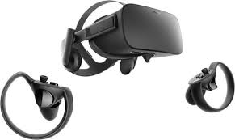

1. An Example of a VR Headset

This idea of combining video gaming with education is called game-based learning, also known as GBL. An example idea of a game-based learning application combines the puzzle-solving of *Zelda* with the shooting of *Call of Duty.* This combination allows the player to solve puzzles teaching various concepts taught in class such as a class on circuitry while also letting them unwind between puzzles by mindlessly shooting down enemies. Ideally, the GBL application would have an equal mix between shooting and learning so the player is learning without being burnt out from just learning without a moment to relax.

## Objective

The overarching goal of the project is to create a game for engineering students learning digital logic circuits that both teach them elements of the class and engages them in the game world.

## Design Requirements

The game will follow along these design requirements:

* A Duration of 30 minutes
* Interactions with the world.
* 5 Digital Logic Circuit puzzles to solve
* A 5 Question Final Exam
* Virtual Reality Compatibility
* Essentially, a puzzle+action shooter.

## Design Constraints

The virtual reality technology provided by the institution provides the biggest restraint in this project. Therefore, the project has to work around these design constraints:

* Work with the institution’s HTC Vive VR Headset
* Work through a limited play area the size of a classroom
* Last a maximum of 30 minutes to reduce the risk of headaches to those unfamiliar with VR gaming.

## Design Approach

The design for this game is split into three intertwined parts: the story, the world, and the puzzles. Without a story, there is no reason for the world to exist. Without the puzzles, there is no reason to create this game utilizing GBL. Without the world, there is no game. In order to create the game, the story must be established. Figure 3 below showcases this design approach.

In this case, the story involves the player winding up deep within an engineering facility. They must get a feel of their situation and try to escape the facility. Along the way, the player will encounter two types of enemies. The first are the previous people who were rendered braindead from struggling to solve the puzzles. The second is the security guards sent by the facility’s boss as a result of fear for the facility’s secrets being exposed. After being confronted by the boss, the player will be challenged to one last quiz and then sent to an unknown facility somewhere in space.

The world is developed based on the story. The world takes place within a hidden testing chamber of an engineering facility. The facility was purposed to teach their trainees digital logic circuits. However, years have passed, and no one has solved all four of its puzzles. These trainees have become braindead and with attack anyone who gets in their line of sight. Over time, the player will learn than the facility is holding a secret the boss does not want to have leaked. The boss will send security to stop the player the closer they are to the end.

From there, the basis for what the player will see can be made. There will be a visible health bar with the health having a max value that increases twice throughout the puzzles. The puzzles will also award players with two weapon upgrades just in time for the elite enemies towards the end. Because of the limited movement space, the player will also be allowed to teleport to bypass this limitation. Since each room and hallway will be its own scene in Unity, each time a new scene is loaded, that scene will become the respawn point should the player lose their health points.

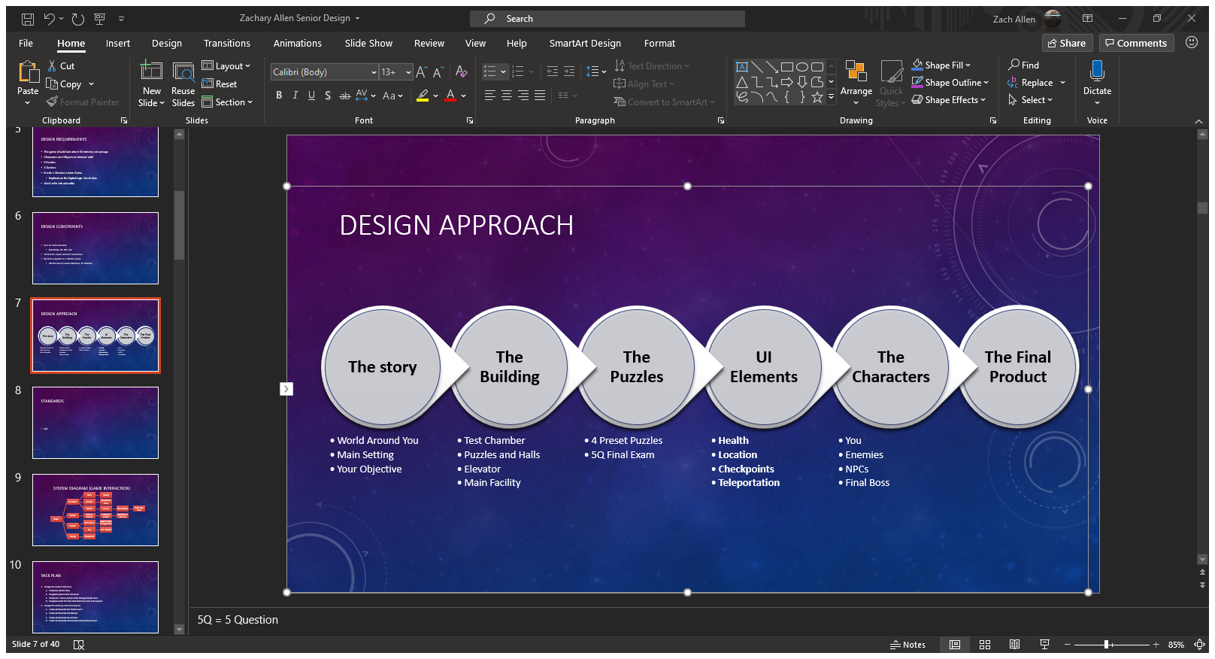

1. Design Approach
2. Project Description

## System Description

This game will utilize Unity and virtual reality. The player’s movements combined with their controller inputs dictate how the game is controlled. There will be button inputs for helping with puzzles, beating down enemies, and teleporting around rooms larger than the VR play area.

## System Diagram

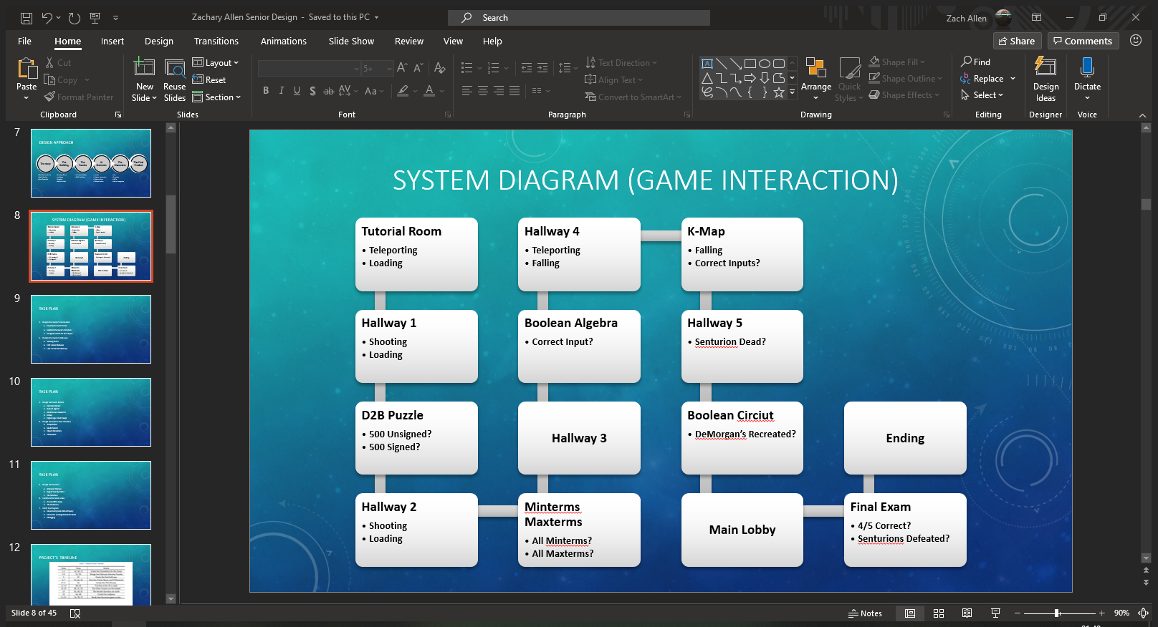

1. The Game's System Diagram

## System Functions

The most prominent functions this system has is the teleporting and loading functions. The teleporting functions allow movement throughout the entire game while factoring the limited play space the player will have to deal with. The loading functions allow each scene to be loaded from the previous scene and serve as a checkpoint throughout the game. The shooting function also exists to shoot down enemies that appear in your way as you advance through the game. These three functions exist throughout the entire game where each puzzle room, the last hallway, and the final exam has functions exclusive to their scene.

The puzzles all have functions to check to see if the player has performed the correct solution to each puzzle. For the decimal to binary puzzle, the function checks if they placed the correct unsigned input to access the second half of the puzzle and another one checks if they placed the correct signed input to enter the second hallway. The minterm and maxterm puzzle checks to see if all of the boxes are placed in the correct location representing minterm and maxterm before taking people to the next hallway. The Boolean algebra puzzle checks for the correct input before taking players to the next area and punishing the player slightly if they were incorrect. The K-map puzzle checks to see if the player stepped on all the right panels before sending them to the last hallway. Finally, the circuit puzzle room checks to see if they recreated the assigned circuit before sending them to the main lobby.

The fourth hallway and K-map room both display a unique function called falling. This is to punish the player for not standing on the floor or real floor while navigating these rooms. This would result in a game over and a reset to the start of the room they fell off of. The Final Exam also have unique functions that are called depending on how the player performs. If they get 4/5 questions right, the Senturions are ignored and the player is sent to the ending. Otherwise, they will face the 2 Senturions and the game will proceed with the ending once they are both defeated.

1. Implementation Plan

## Tasks

* Task 1: Design the Game’s Foundation
  + Subtask A: Develop the Game’s Plot
  + Subtask B: Establish the Game’s Structure
  + Subtask C: Designate Assets to Create the Project
* Task 2: Design the Hallways of the Game
  + Subtask A: The Starting Room
  + Subtask B: Basic Hallways
  + Subtask C: Advanced Hallways
* Task 3: Design the Puzzle Rooms
  + Subtask A: Decimal to Binary
  + Subtask B: Minterms and Maxterms
  + Subtask C: Boolean Algebra
  + Subtask D: K-Map
  + Subtask E: Digital Logic Circuit Design
* Task 4: Create the Game’s UI Elements
  + Subtask A: Enable Teleportation
  + Subtask B: Create an HP System
  + Subtask C: Establish Interactivity with the Objects
  + Subtask D: Make the Checkpoint System
* Task 5: Design the Game’s Enemies
  + Subtask A: Braindead Trainees
  + Subtask B: Regular Security Patrol
  + Subtask C: The Boss’ Elite Guard
* Task 6: Create the Main Lobby
  + Subtask A: A Live Office
  + Subtask B: The Final Exam
* Task 7: Verify the Program
  + Subtask A: Ensure Every Event Works Properly
  + Subtask B: Ensure Each Scene is Loaded One After Another
  + Subtask C: Debug the Game

## Team Organization

This project will be completed by one person. As such, Zachary Allen will be solely responsible for the completion of each task shown in the timeline. The timeline below shows what is to be expected after each week until it is time for the final presentation

## Timeline/Milestones/Delivery Plan

1. Planned Project Timeline

|  |  |  |
| --- | --- | --- |
| Week | Tasks | Details |
| 1-2 | 1A, 1B, 1C | Create the Foundation for the Game |
| 3-4 | 2A, 2B, | Design the Hallways between Puzzles |
| 5 | 2C | Create the final hallways |
| 6-7 | 3A, 4A, 4C | Start the Puzzle Room and UI Elements |
| 8-11 | 5A | Create the First Enemy |
| 12-14 | 4B, 4D | The Rest of the UI is made |
| 16-18 | 3B, 3C, 3D | The Other Puzzles are developed |
| 19 | 3E, 5B, 5C | The Harder Enemies are made |
| 20 | 6A, 6B | Create the endgame |
| 21-22 | 7A, 7B, 7C | Verify that the entire game works. |

1. Implementation

This section of the report will go through each task and mention how they have been implemented throughout the project.

## Implementation of Task 1.

This task is meant to develop the cornerstone for this entire game. This means the story, structure, and assets used are determined in this task. By establishing a foundation for the game, the rest of the tasks can follow suit as the game is being developed.

### Implementation of Subtask 1A

This task established the plotline for this game. For this adventure, the player is a trainee who got trapped within the facility’s training chambers. The player wakes up and must try to leave the chamber. They will solve the facility’s digital logic circuit puzzles and take down other trainees who became braindead throughout the testing process. As the game goes on, the player will learn that the antagonist did not mean for anyone to clear the chambers and will start to send his security personnel to stop the player. After confronting the boss and clearing his final exam, the player will be sent away so the boss’s secrets can remain hidden from the public eye. Where the player ends up is the basis for another GBL Senior Design Project involving puzzles in circuits.

### Implementation of Subtask 1B

Now that the game’s story is set, the task to develop the game’s structure is afoot. Originally, the game would take place in one large chamber with winding hallways connecting to each puzzle room as shown in the figure below. However, this idea was eventually scrapped after realizing the player could not realistically navigate a large, winding facility.

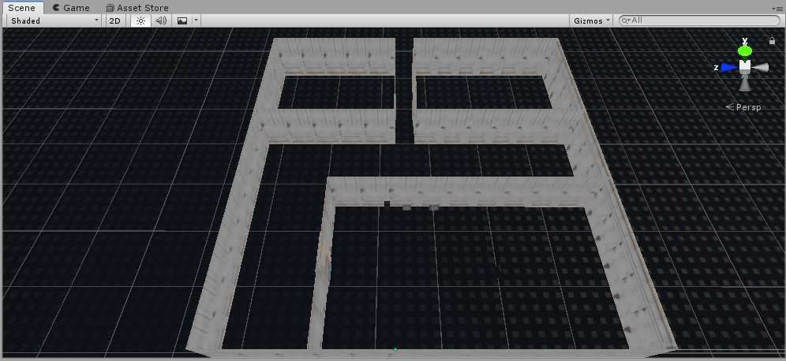

1. The Game's Original Structure

Therefore, the game took on a new structure. This structure takes full advantage of loading scenes in and out while compensating for the limited virtual reality movements. Each room, therefore, became its own scene in the final project with a script loading between each room as the player leaves the room before. This also includes the hallways connecting each room. The way this project is split is shown in the figure below. Each scene is its own unity file in the Scenes folder. This feature is done through the Unity Editor itself.

From the main screen, one could go to the File dropdown menu on the toolbar and create a “New Scene.” From there, the person could right-click the scene name from the Hierarchy section of the editor and choose “Save Scene.” Then, they could go to the application’s “Scenes” folder and save the scene to a name of their choosing. For this project, this had to be done for all 12 scenes in the game from the first room to the five hallways to the five puzzle rooms to the main lobby.

Future implementation allows the game to load from one scene to the next within this folder. Even so, the rooms are still bigger than the play area allotted for virtual reality use. Therefore, teleportation must be used as explained later on in the Implementation section.

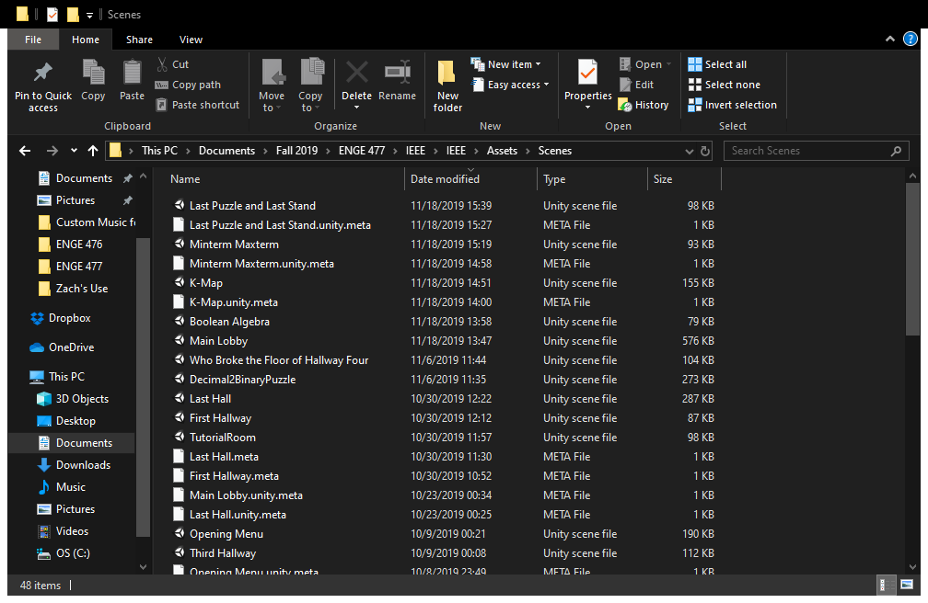

1. The Scenes Folder, Showcasing the Game's Structure

### Implementation of Subtask 1C

With the story and structure of the game established, the time came to establish the assets the project will use. All of the assets will be mentioned in the Acknowledgements section with credit to their creators. The assets to keep in mind were those that fit with the desired aesthetic the game was going for and makes the world actually look like it takes place in a rundown engineering facility. One important asset to mention, however, is the SteamVR asset. This asset allows this project to run through its full potential by enabling this game to run in virtual reality. This asset also makes movement through larger rooms possible with the teleportation feature. This feature, itself, is implemented in a later task.

## Implementation of Task 2.

This task begins building the rooms the facility will go through. To start things off, the player will begin in the first room of the facility and will then go through a dark hallway to get to the first puzzle. With the structure being room then hallway and then room and so on, the first step would be to create the first room and the hallways to navigate.

The layout for the game is defined in the figure below. The game starts in the room on the top left of the figure that serves as a tutorial room for new players. From there, they would go through five rooms connected by hallways of varying lengths. At the end of the last puzzle room on the bottom of the figure, the player would then get sent to the main lobby of the facility, which is implemented later on in the development process.

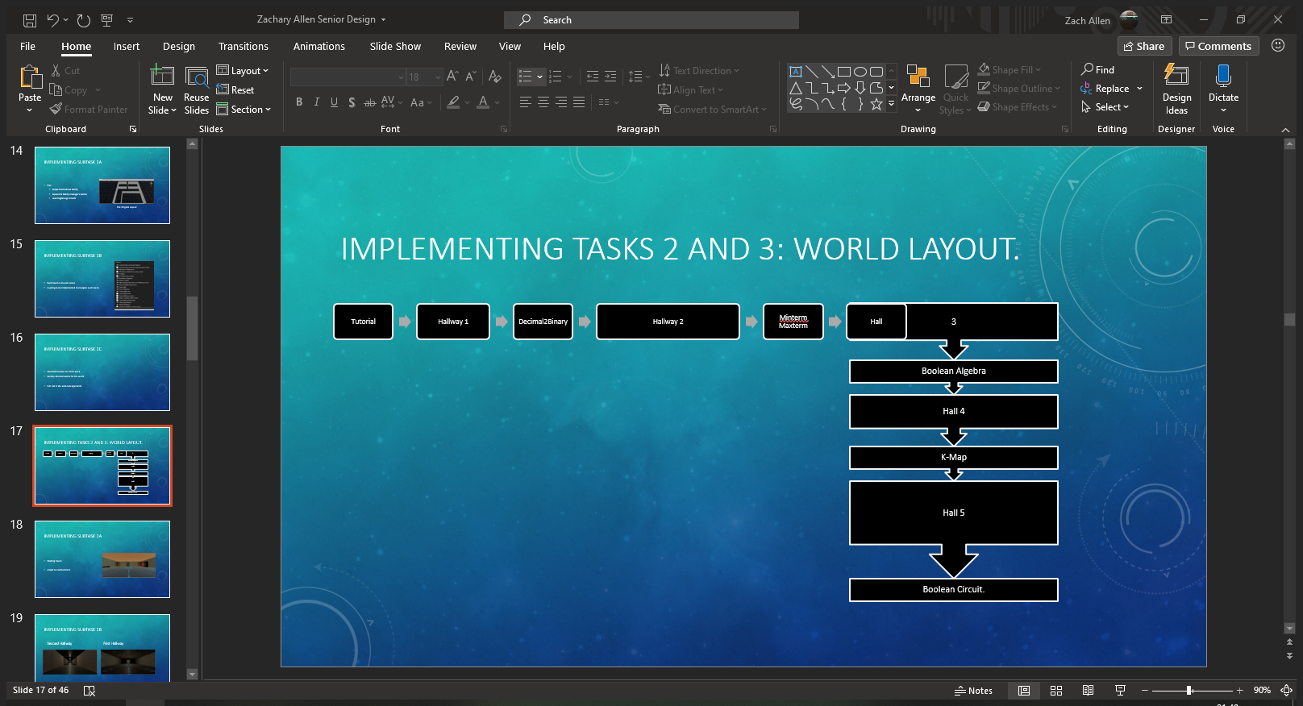

1. How the World Flows

### Implementation of Subtask 2A

The game begins in a surprisingly lit room deep inside the testing chambers. In the lore, these rooms are where trainees begin to complete their run through the facility to clear each puzzle. Such a room is implemented as shown in the figure below. The player will use this room to get familiar with the controls and proceed to the first hallway once acclimated with the controls.

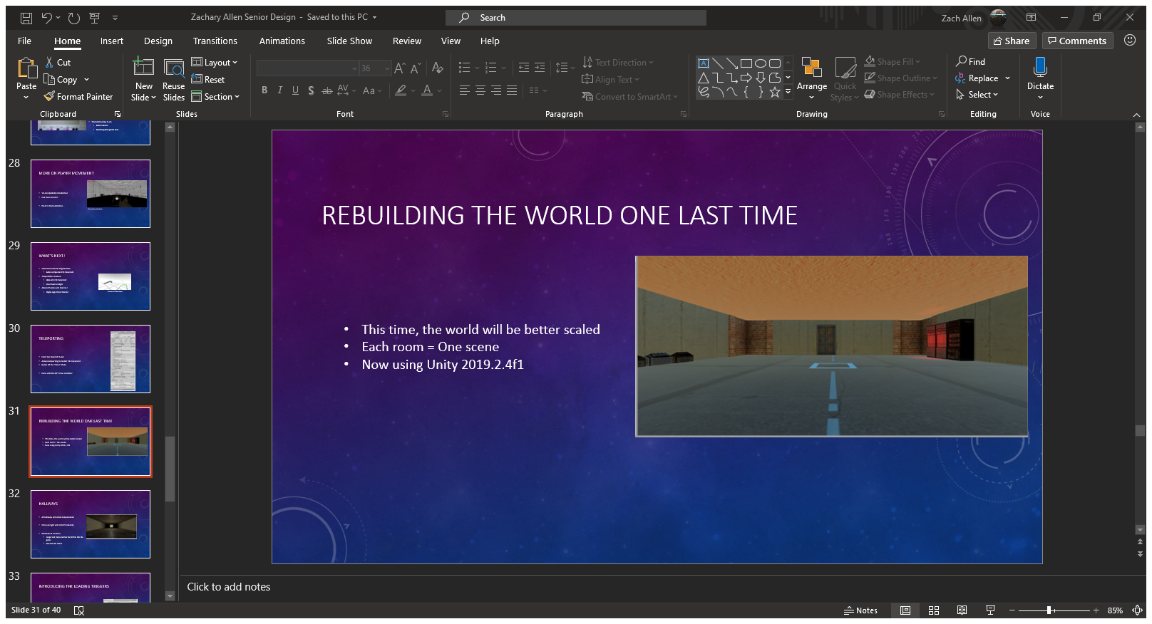

1. The First Room

All of the designs for the rooms and hallways for this application was done through the Unity Editor. The figure below shows the interface users are greeted with. The toolbar at the top of the editor allows users to create new objects and define various parameters with the game like animations and lighting. The screen in the middle shows the scene the user is working on. There is a “Scene” view where the user can move around the world’s 3D grid to design their world to the fullest extent of their imagination using the assets taken from the Asset Store or what they defined. The “Asset Store” is also a tab the user can go to purchase new assets and import them into their project. Between the two tabs is the “Game” tab that shows how the game will look through the game’s defined camera. On the left is the hierarchy of the scene they are working on. This shows all the parts the user has placed on the current scene and their relationship to each other. When one is clicked on, its attributes are shown on the right side of the screen. This includes its location, transformation, parameters, and even collision. Below the screen shows all the folders that are defined in the project including imported assets, defined scripts, and scenes created for the game. The prefabs shown here can be clicked and dragged onto the center of the screen to be placed within the game itself. This process is used to create every single room in this game.

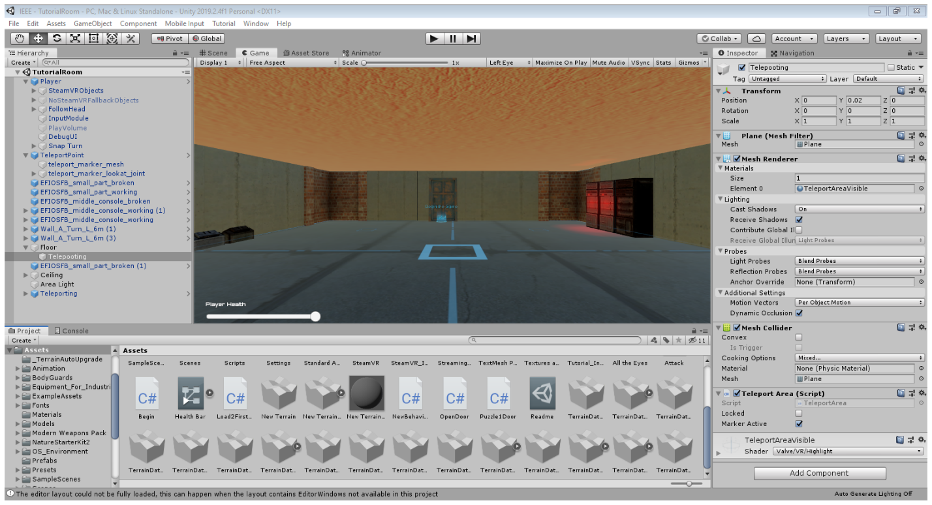

1. The Unity Editor Interface

### Implementation of Subtask 2B

Once the first room was built, the next objective was to create the 5 total hallways the game will have. There will be 3 simple-to-navigate hallways and 2 more advanced ones as the game progresses. This subtask focuses on the first 3 hallways. The first hallway is shown in the caption below. This room is very dark compared to the starting room and introduces the player to the first enemy of the game. However, this hallway is short, and the player can easily circumvent the enemies. This first hallway serves as an introduction to the game’s theme of a rundown facility. The hallway is faintly lit and the enemies within are shadowy shells of their past self with no drive or motive at all. Clearing this hallway grants the player access to the decimal-to-binary puzzle.

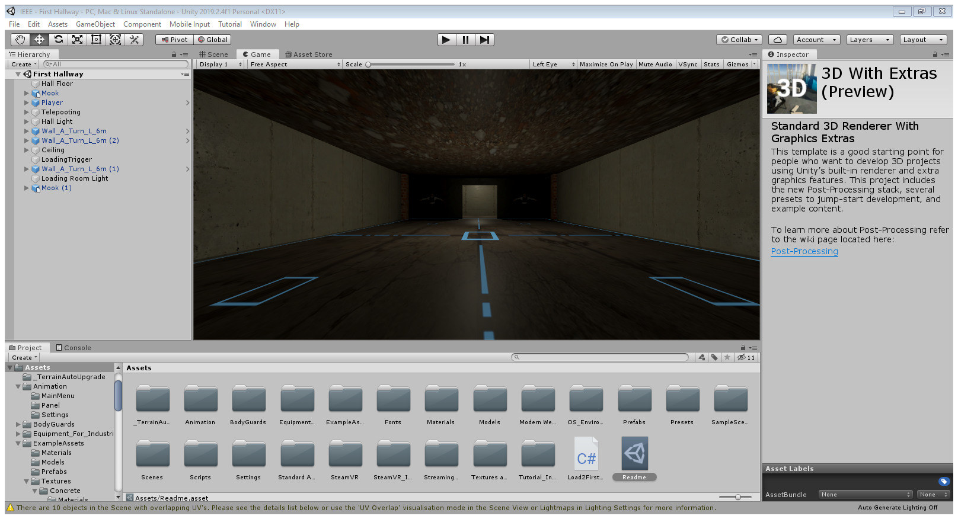

1. First Hallway

The second hallway is shown in the next figure below. This hallway is longer than the first one and even has a brief outdoor view. This hallway works with the same philosophy as the first hallway, except more focus is placed on showing how each hallway in the game is different. The first hallway is a dark place, giving the player a taste of how rundown the facility really is. This hallway has more light and even a window to look through. Like the first hallway, this one is a straight shot from point A to point B to get to the next puzzle that will involve minterms and maxterms.

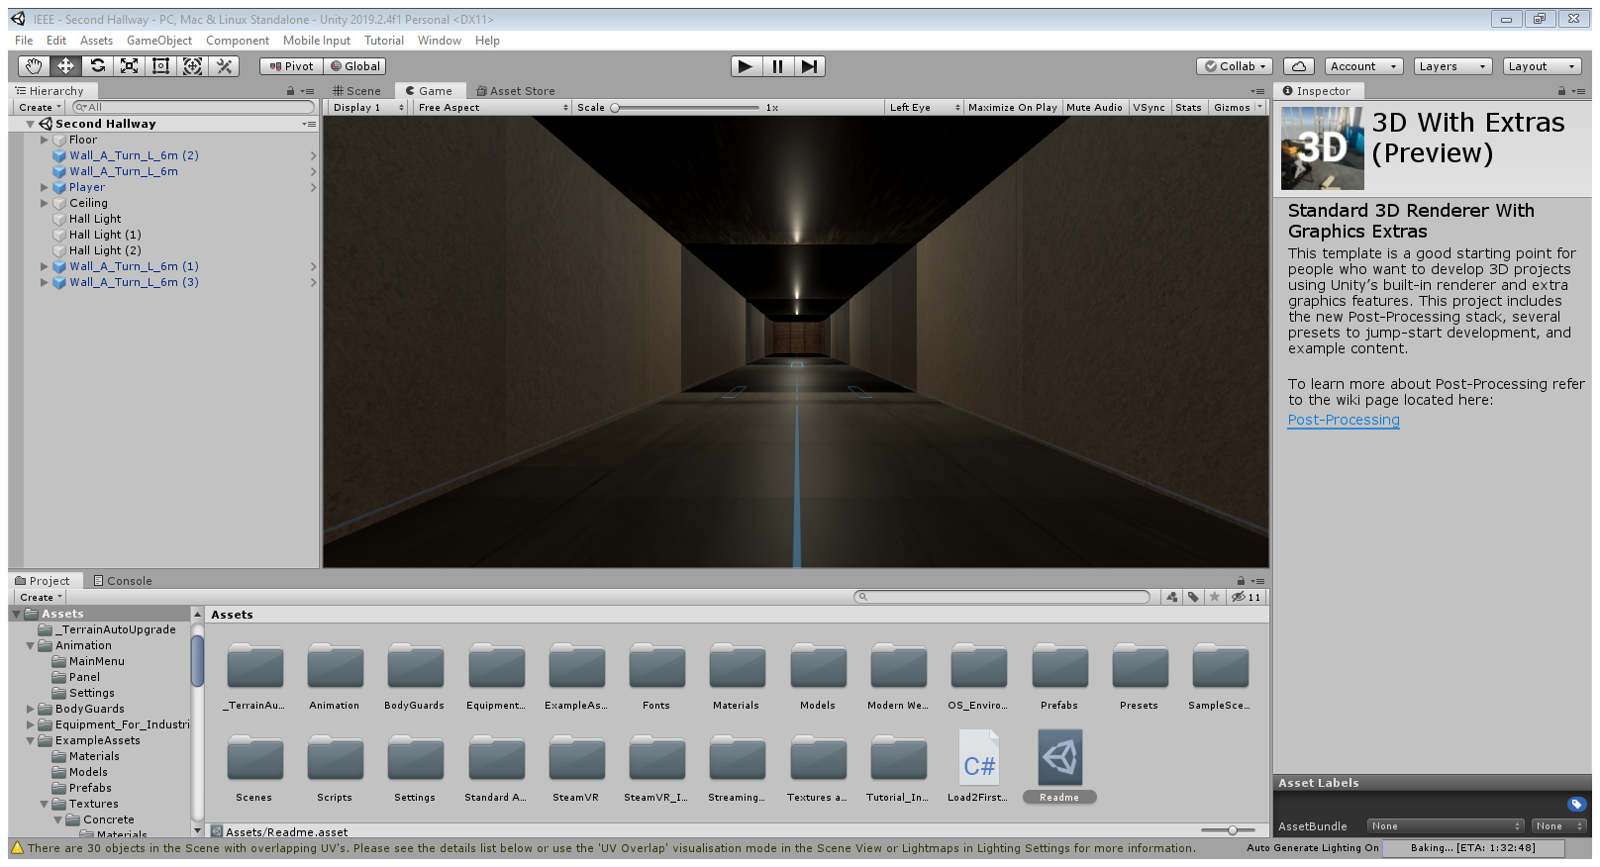

1. Second Hallway

The last simple hallway is shown below. This one bends at a 90-degree angle. This hallway will introduce the second enemy type of the game where the story escalated to the boss starting to actively keep the player in the testing facilities. The boss even tries to drop all the lights in this hallway to stop any further progression and mask any movement the bodyguard patrolling this hallway would make. These enemies will have slightly higher health than the first enemy type and are generally more ruthless. Clearing this hallway sends players to the Boolean algebra puzzle.

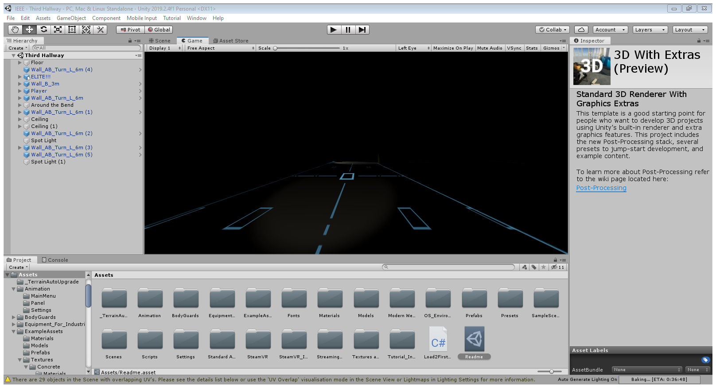

1. Third Hallway

### Implementation of Subtask 2C

As mentioned in the above section, this game has 5 hallways. This subtask will implement the final two hallways the player will encounter. The first one is shown below. Here, the player must teleport between chopped off sections of flooring and avoid falling to meet the past victims of this accursed hallway. The idea behind this hallway is to take a break from the flat hallways with a couple of enemies at the end and focus on a hallway more oriented around player movement. Since they can be assumed to be more familiar with how VR movement and teleportation works at this point in the game, this hallway tests their knowledge of the movement physics of the game. Of course, should they fall, they will just restart at the beginning of the room rather than all the way back in the first room of the game. This way, the player can just immediately try again and not get burnt out having to backtrack all the way back to this hallway and solve the same three puzzles over and over. Once they clear this platforming section, they are granted access to the K-Map puzzle.

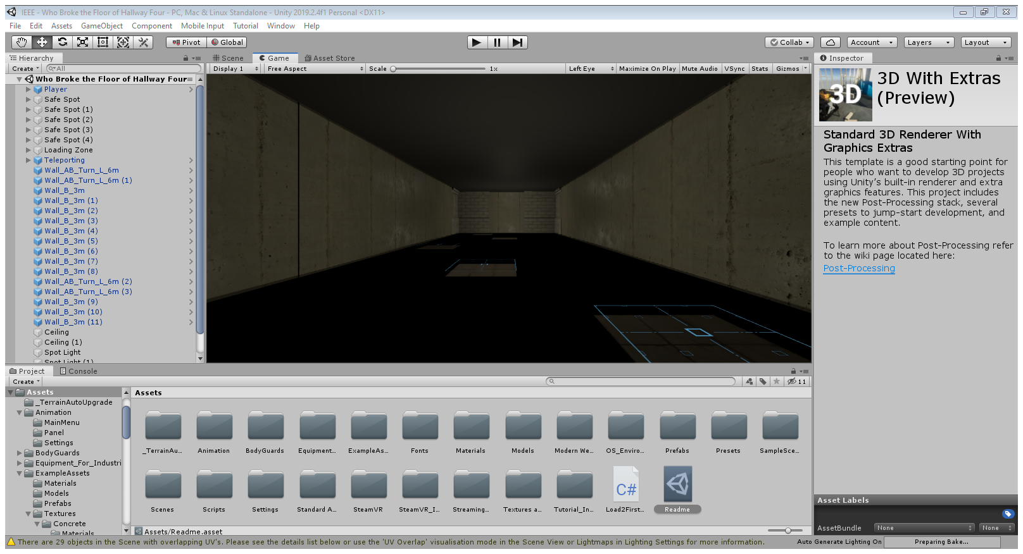

1. Broken 4th Hallway

One more thing to note about the fourth hallway is the creature showcased in the following figure. This is the “Eyes of the Eldritch.” It is an unknown entity with unknown origins and no natural explanation as to why it is under this hallway and why it broke the hallway. Many unfortunate souls have fallen to the eldritch in their journey of the chambers. The Eyes of the Eldritch is introduced into this point in the game to showcase the dark secrets the facility owner is hiding from the public. An aberration threatens to warp the world around the facility, creating anomalies in the reality around it. It is also possible that the facility defined a cult around this aberration and sends test subjects to suffer through the test facilities as an offering. Regardless, this creature is a threat that must not go unchecked and has to be taken care of after escaping the facility and contacting the authorities.

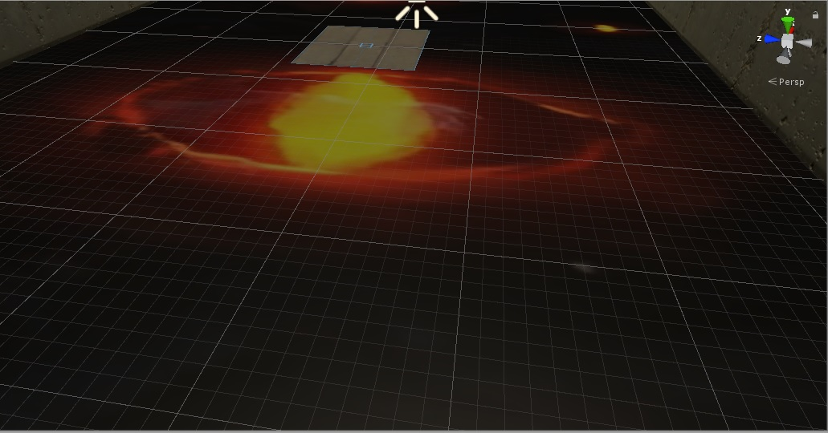

1. Eyes of the Eldritch

The last hallway is represented by the figure below. This hallway features both elevation and broken floors. The idea behind this hallway is to create a navigation final exam that utilizes both the knowledge learned from the teleportation hallway and knowledge gained from navigating a hallway that is both three-dimensional and features holes in the floor. The aberration itself is absent from this hallway as it holds residence around the area of the previous hallway and the K-map puzzle room. The end of the hallway has a boss battle preventing the player from accessing the final puzzle and the main lobby. This showcases the story escalation where the boss is in real danger by the player and is willing to send out his strongest bodyguards to prevent his secrets from being exposed. This also allows the player to prove what they learned through the combination of shooting enemies and moving around the room to do so efficiently. Details about the boss is detailed in its respective implementation section. Defeating this boss opens the way to the final puzzle of the game while the boss still has his eyes on the player.

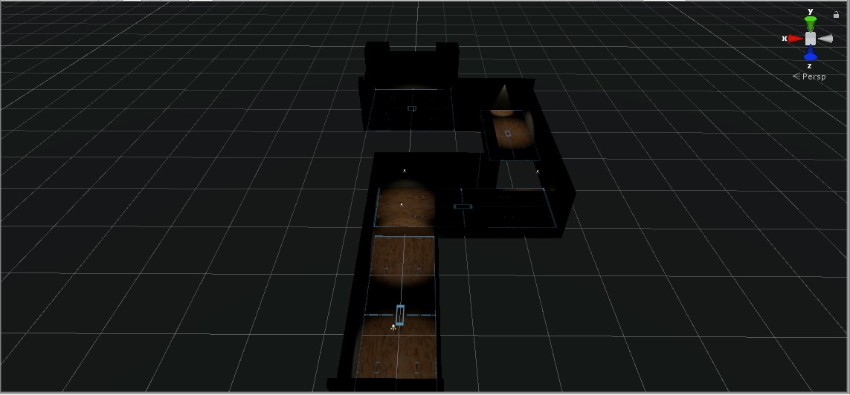

1. Overhead View of Last Hallway

## Implementation of Task 3

Once the hallways are built and established, the next task of creating the puzzles can be implemented. The purpose of these puzzles is to test the player’s knowledge of digital logic circuits. The first four puzzles also come with a reward system that will help the player in their journey. The rewards alternate between a damage buff and a damage reduction from enemies. Completing the final puzzle will grant the player access to the main lobby and the end game.

### Implementation of Subtask 3A

The first puzzle has the player doing a simple conversion from decimal to binary. This puzzle has 2 parts: the first conversion and then taking the 2’s complement of the first number. The player will need to know numbers from -512 to +1023 to be able to do the conversion since the puzzle uses a 10-bit system. For this puzzle, the decimal number that will need to be converted to binary and its 2’s complement is 500 in reference to song lyrics posted on the wall with the instructions.

The puzzle is shown in the figure below. The puzzle consists of 10 lights with respective buttons below. Red lights represent a “0” and green lights represent a “1.” The puzzle defaults to all values being 0. Once the correct combination of 1’s and 0’s is made, the door opens to the 2’s complement puzzle. Completing that puzzle allows the player to enter the next hallway and grants them an extra 15 damage to their attacks. This goes hand in hand with the user interface shown in a later implementation.

For this to work, the top row of squares are cubes that can alternate between red and green when pressing the corresponding buttons below. For instance, if the player presses the button corresponding to the square representing 2^3, that square would change from red to green. This means that the square is now a “1” rather than a “0.” The player would do this for all 10 buttons until they created the number representing 500.

This puzzle is also done a second time to representing the 2’s complement of 500. This iteration of the puzzle grants the buff and access to the second hallway. This was also created to combat the original design flaw of this puzzle. Despite teleportation not working through walls, the player could still teleport to the wall, stretch their arm through the wall, and just teleport through the wall as such. While this measure does not prevent the clipping through walls, the measure still ensures that the player *has* to solve the puzzle no matter what.

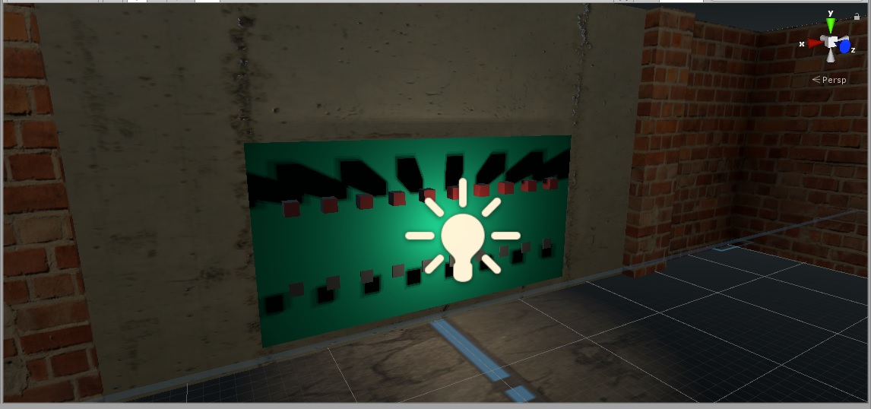

1. The Decimal to Binary Puzzle

### Implementation of Subtask 3B

The second puzzle the player will encounter is a simple minterm and maxterm puzzle. The figure below showcases how the room is designed through the Unity Editor. The player will be presented with a truth table, 8 products of the truth table itself as movable boxes and two pedestals labeled “Minterm” and “Maxterm.” By placing each box in the right basket, the player will be able to advance to the 90-degree hallway and continue the game. The player will also be rewarded with 25% reduced damage that will stack with another puzzle’s reward later on.

Here, the eight boxes are grabbable by the player. They can pick up each individual box and place them in their respective pedestals. This is done by the grip commands on the HTC Vive controllers. If the expression on the box yields “0” according to the truth table, then the box is considered a minterm and should be placed on that pedestal. Likewise, an expression yielding “1” as the output means the box for that expression should be placed on the maxterm pedestal. The pedestals will light up once every expression is corrected placed on it. Once both pedestals are lit up, the puzzle is cleared and access to the next hallway is granted.

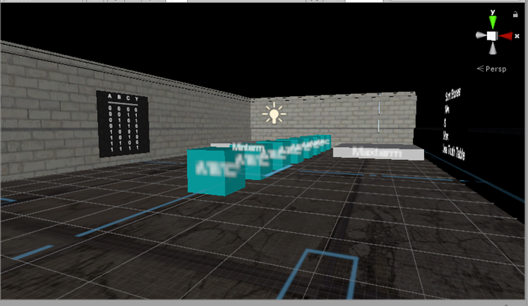

1. Minterm and Maxterm Puzzle Room

### Implementation of Subtask 3C

The third puzzle players will encounter involves utilizing Boolean Algebra to simplify two functions presented. The figure below showcases the room’s layout. The room will feature a post featuring an unsimplified expression. The goal is to use the screen at the end of the room to simplify the expression to solve the puzzle. Each wrong guess will cause a flat 10 damage penalty, so the player must plan accordingly before throwing random guesses into the air. Completing this puzzle will reward the second damage boost and allows them to visit the Eyes of the Eldritch.

This puzzle is a test of the player’s Boolean algebra knowledge. The player will need an understanding of the various rules in simplifying Boolean expressions. For instance, “A+A’” will always cancel out and result in an output of “1” if it appears in the expression. Once they get an understanding of the Boolean identities and figure out the expression, they can go over to the panel across from the view in the figure and an input panel will appear. Like mentioned, there is only one correct input and the player has until they run out of health to keep trying. They can use their hand motions in the VR space to touch each key on the input panel and hit the confirmation button to test their answer.

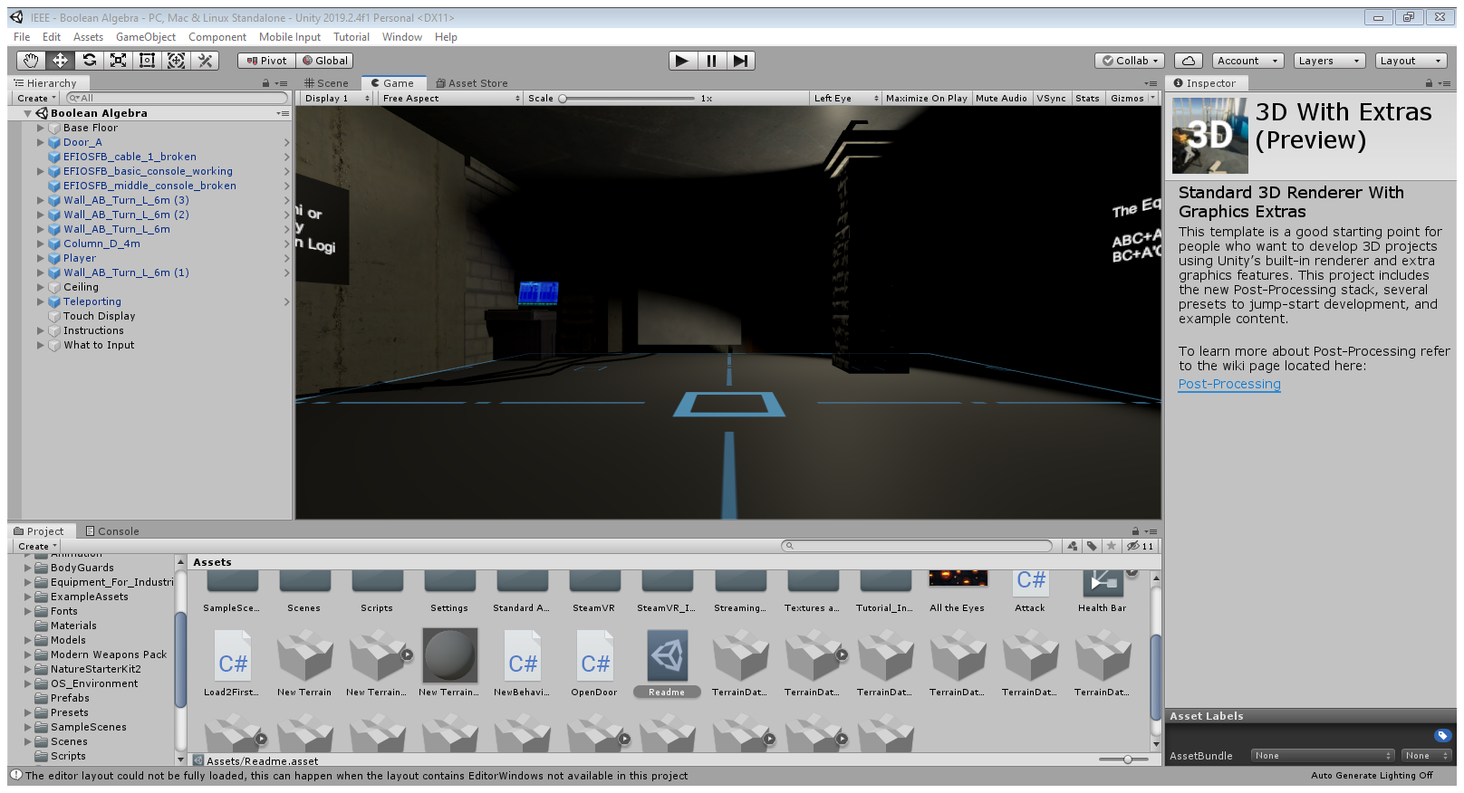

1. Boolean Algebra Puzzle Room

### Implementation of Subtask 3D

The next puzzle uses another truth table with 8 lines. However, the room will have 8 squares on the floor. Below this room is the Eyes of the Eldritch. Any incorrect input will drop the player to its eternal deadly stare. The player must step only on the squares that outputs a 1 from the truth table. Therefore, the player is using their feet to create a K-map of the provided truth table. This puzzle presents the final reward of the second 25% damage reduction, just in time for the last hallway and its impending boss battle.

Since teleportation is part of the game’s system, the first issue with creating a puzzle with fake and regular floors is how to mask each floor so the player is not immediately spoiled the answer. The floors on each of the figures have a distinct blue pattern that shows that the player can teleport where they are currently standing to other areas with this blue pattern. Of course, if this applied to the 8 squares that represent the K-map, the solution would easily be spoiled, and the player would not learn how K-maps work properly.

The solution then was to hide the teleportation floor design itself over the K-map area. While this does not the player from abusing the teleportation feature to cheese the puzzle, they will still have to make sure they teleport to the right panels and do not accidentally walk off the puzzle area. The fake panels also have their collision removed from within the Unity Editor, so the player walks through them rather than on them and fall to their demise. Once the game registers that the player stepped on the correct panels of the K-map, the game will send the player on their way to the final stretch of the game.

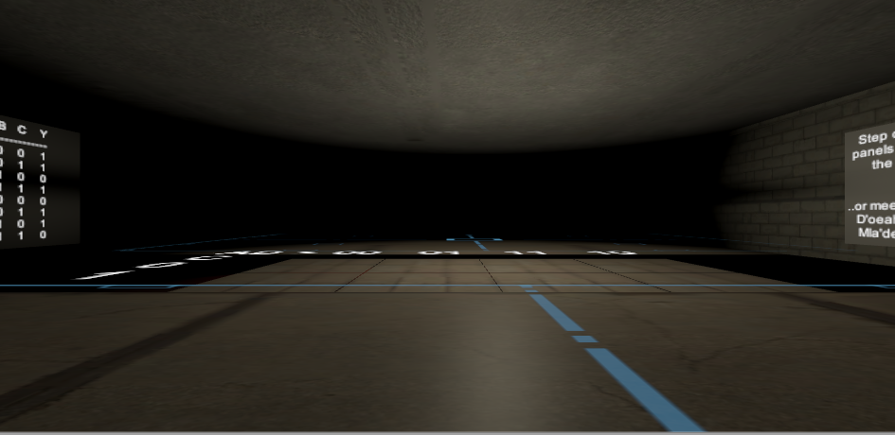

1. K-Map Puzzle Room

### Implementation of Subtask 3E

The final puzzle takes what the player has learned over the past four puzzles and requires them to create a Boolean logic circuit. The room will feature an expression and a board with logic gates to put into the proper equation. Only by making the right circuit can the player advance to the main lobby.

Furthermore, the room also comes equipped with an enemy spawner. Every minute the player spends in the puzzle, a second-tier enemy comes to interrupt the puzzle-solving. The player will have to juggle solving the puzzle and control the enemies to ensure proper completion of the puzzle with minimal damage.

For the circuit, the instructions mention DeMorgan’s Theorem where (AB)’ = A’ + B’. This is one of the first Boolean identities taught in digital logic circuits, and the puzzle asks for this circuit to be recreated. Luckily, there are small, grabbable gates that are used to solve the puzzle. By connecting the AND, NOT, and OR gates properly, the player can recreate DeMorgan’s Theorem and clear the puzzle while juggling enemies that interfere every minute.

The enemies are placed out of the main room. This is to ensure they are loaded in when the player enters the room. There are 10 preset enemies that will get in the way, assuming the player takes 10 minutes to solve the puzzle at a maximum. Once each minute has passed, the enemy is then transported to the center of the room where they will immediately try to halt the player’s progress. Being able to manage the enemies without losing track of the puzzle at hand is essential to being able to recreate the circuit and advance to the final area of the game.

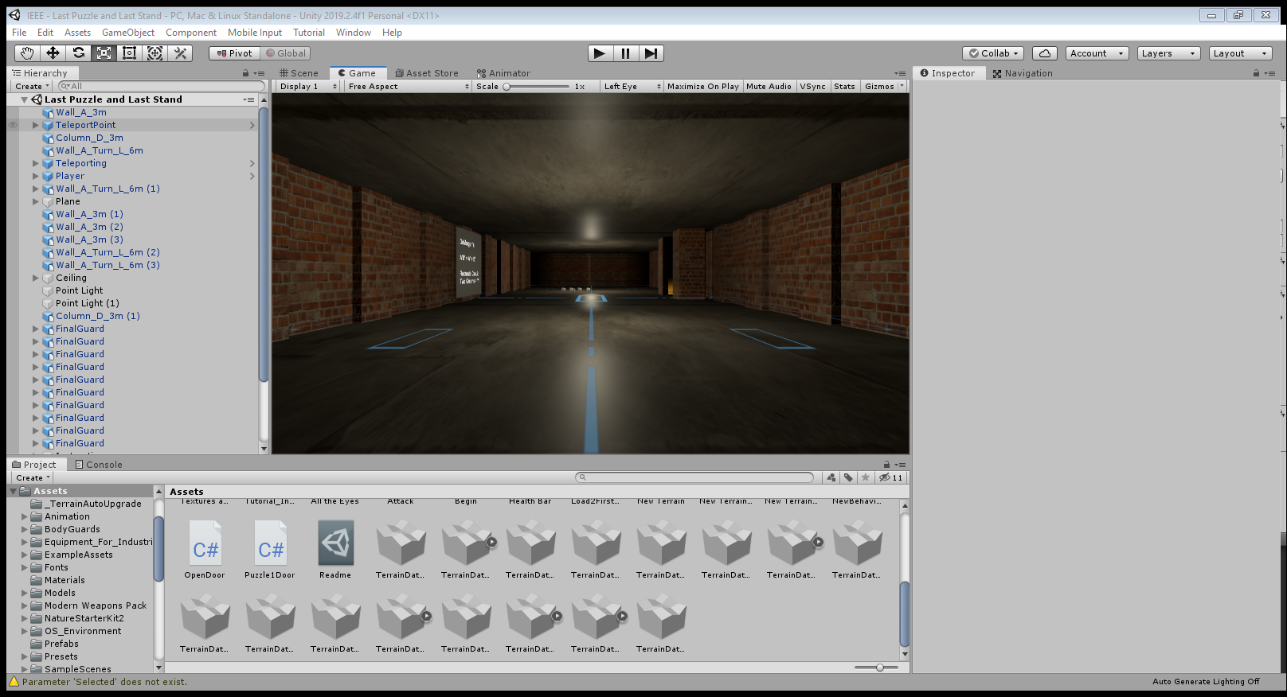

1. Final Puzzle Room Layout

## Implementation of Task 4

Once the world is established as well as its puzzles, the user interface elements must be created. This includes the way the player moves around the world, how the world can be interacted with, and how to prevent the player from having to restart the *entire* game after each game over. Since the UI elements of this game is done through C# code, these subtasks will refer to the Appendix for each of the subsections’ respective script file.

### Implementation of Subtask 4A

Because of the limited mobility of the HTC Vive and how large each of the scenes in the game are, basic moving will not be enough to navigate the game. The solution to this problem is to apply teleportation to the game. This is established by using the SteamVR asset in Unity. For the sake of this project, teleportation is achieved by duplicating the floors of each room and establishing a teleportation layer for each floor that has collision. The results of this action are shown in the figure below. The teleporting layer of the floor itself also has to have collision or the teleporting feature cannot be used. The teleportation itself is performed by using the trackpad of the Vive controllers. This action of teleportation will also be utilized to take players between each room and hallway of the game.

For instance, a Unity game creator wanted to build a floor the size of a gymnasium. If the playroom is the size of a small classroom, then whoever tests the VR environment would not be able to go far in the gym. What the creator would then do is take the floor they made, duplicate the floor, set it as a “child” of the main floor, set the floor up to be slightly higher than the original floor, and add SteamVR’s “Teleport Area” onto the duplicated floor. From there, they would go to SteamVR’s prefabs and select “Teleporting” to enable teleportation throughout the entire floor. Now, the player can navigate the entire gymnasium in a room the size of a small classroom by utilizing the trackpad on the HTC Vive controller.

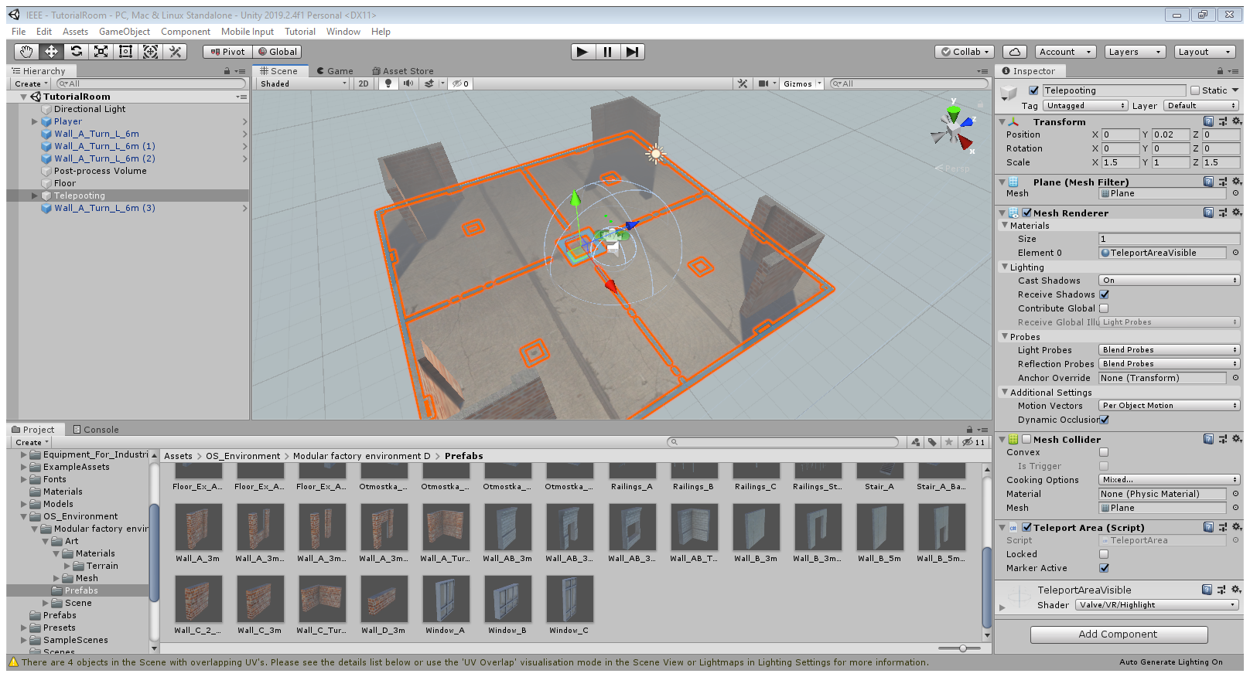

1. Teleporting as Shown in the Unity Editor

### Implementation of Subtask 4B

A game is no fun if there is no risk involved with how one plays it. That is why games usually come with a health system to encourage players to think carefully and provide a boost of adrenaline should they make it out of a rough encounter by the skin of their teeth.

This game will also come implemented with a health system. The player will have a base health of 100 with damage modifications that reduce their damage from enemies after solving the second and fourth puzzles. Enemies will also drop healing caplets to heal the player from any damage taken. What happens when the player reaches 0 health will be explained in subtask 4D.

A player health script is essential to any action game. This script utilizes the slider bar’s scripting to showcase how much health the player has left with respect to the cap of 100. This slider bar can be seen in the figure below. When looking straight ahead, the health bar will appear on the bottom left corner of the screen. The size of the bar is small to avoid blocking important information being received from the playing field yet noticeable enough to see the player’s current health at a quick glance. Every damage taken is represented by a brief flash on the screen and the bar sliding left. The bar sliding right only happens when the player heals any damage taken. Once their health reaches 0, however, the later-implemented checkpoint system kicks in and resets the player back to max health and at the start of their current room.

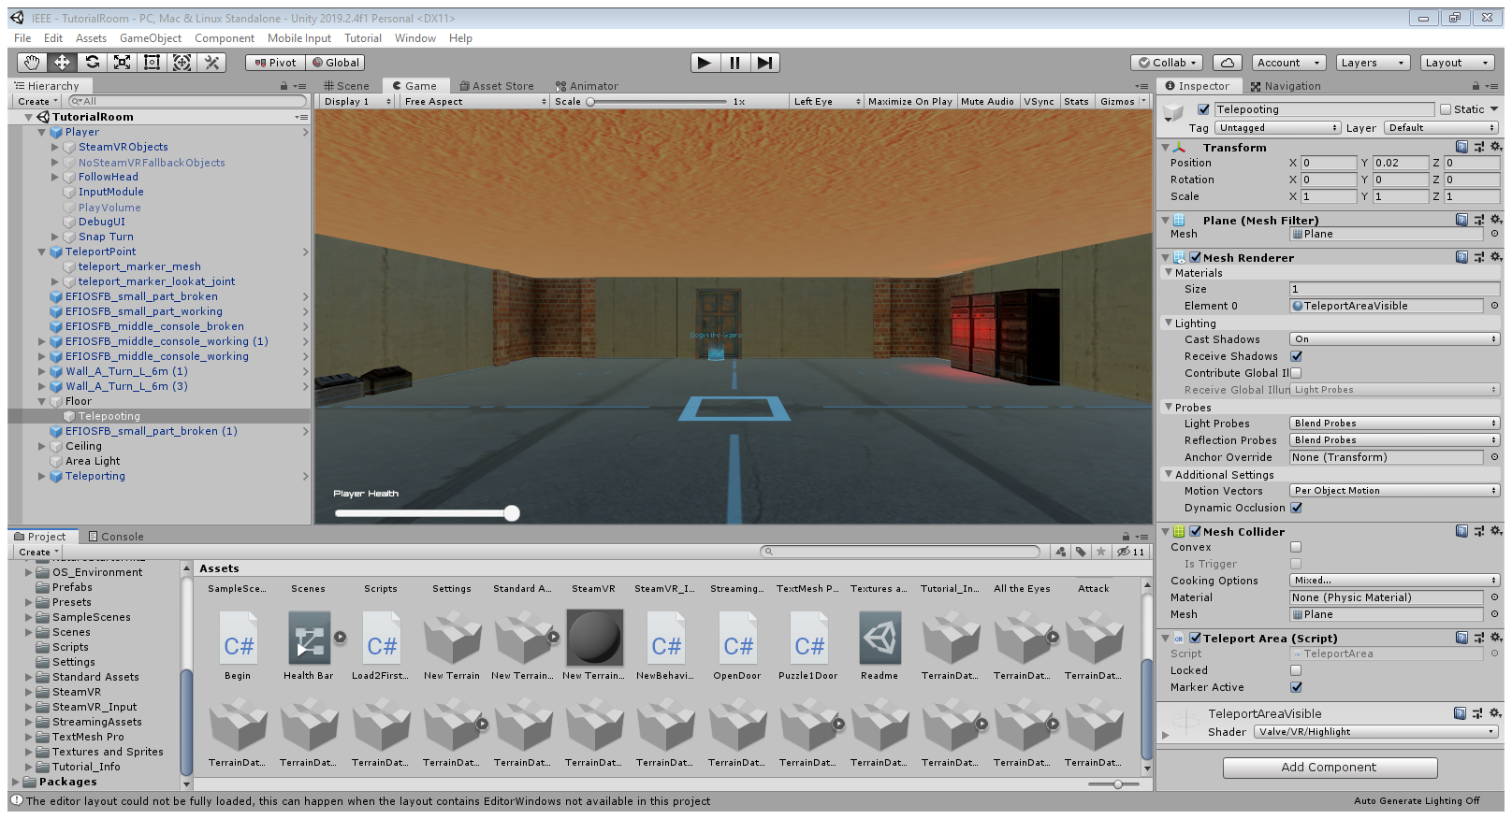

1. Showcasing the Health Bar

### Implementation of Subtask 4C

In order for the puzzles to work, there must be an ability to interact with the objects in the world. For instance, this subtask implements the ability to push the buttons in the decimal-to-binary puzzle, picking up boxes for the minterm and maxterm puzzle, and interacting with non-playable characters in the game. This task takes advantage of using box colliders and triggers to ensure each puzzle and interaction works as intended.

In the Unity editor, every prefab the player defines onto the current scene comes with predefined colliders. For instance, the mesh collider allows the teleportation feature to be used on the floors of each scene. Another example involves using box colliders. Setting the collider to “Is Trigger” allows the object with the box collider to be interactable with the player. All of these colliders are predefined with the editor software itself.

### Implementation of Subtask 4D

The final UI element in the game is the checkpoint system that the game will run by. The game will run in a way that the respawn scene should the player die will be the same scene that they are currently on. So, if the player dies falling into the Eyes of the Eldritch, they would not have to keep doing the first three puzzles and hallways just to try again. Of course, the player will respawn with all of their health and any progress made against enemies in the room will be saved.

## Implementation of Task 5

A game is boring if the only obstacles are brick wall puzzles that interrupt the pacing of the game. For this reason, this task implements 3 types of enemies into the game. The enemy type the player faces changes with how far they are within the game itself. The scripts that the enemies run on can be seen in the Appendix below.

### Implementation of Subtask 5A

The first enemy players will face are the braindead engineers who have failed the trials the player is currently going through. These enemies are relatively slow, have poor detection, and go down in 3 shots[1]. These enemies will have 25 health points and do base damage of 10 to the player. These enemies will be encountered in the first two hallways of the game.

These enemies exist to showcase the rundown aspect of the facility the player is escaping. Since no one has ever cleared the test facilities, there is no telling what all and who all are still in the facility when it became the player’s turn to clear the facility. These braindead engineers the players face serve as a reminder to the fate of those who do not clear the puzzle: mindless, lifeless, and trapped in a purgatory within the facility itself.

### Implementation of Subtask 5B

Once the player solves the second puzzle, they earn the attention of the game’s antagonist. He is afraid that if the player solves all of the chamber’s puzzles, the company’s dark secrets will be exposed, and the company will go under as a result. Therefore, he will start sending security officials into the facility to stop the player.

These enemies are shown in the figure below. They will have 75 health and will deal 20 base damage to the player. They also move faster than the braindead enemies and can easily overwhelm the player if they are not careful.

Changing to security officials rather than another zombie-variant enemy results in the story changing dynamics as the player progresses as well as adds a difficulty curve to the game. They highlight the exact point where the facility boss starts to take action to prevent the player from leaving the facility. This way, the world feels like it is acting in response to the player’s actions over the course of their adventure.

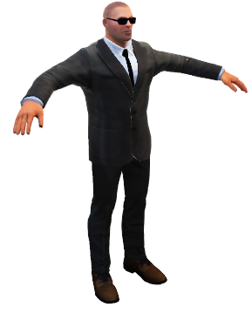

1. T-Posing Model of the Security Enemy

### Implementation of Subtask 5C

Before the player can enter the final puzzle, the antagonist is rendered on red alert. He will send his strongest security official to deal with the player: the Senturion. This hulking bodyguard will have 255 health and deal 40 base damage with each attack. The Senturion serves as the miniboss of the game. Once he reaches half of his current health, he will split into two enemies that have the same health as before the split.

With the basic enemy scripts as a base, the boss runs on a modified version that showcases its increased health pool and attack power. The boss also has a command to split into two when it reaches half of its current health. The duplicate itself spawns at the boss’s current health and will not split as a result.

This point in the story highlights the facility boss’s desperate attempts to stop the player from leaving the facility. By solving four puzzles and seeing the aberration the facility is hiding from the public eye, he shows true fear that such secrets are about to be exposed and sends his strongest troop as a last line of defense before the player can solve the last puzzle that links the facility to the main lobby.

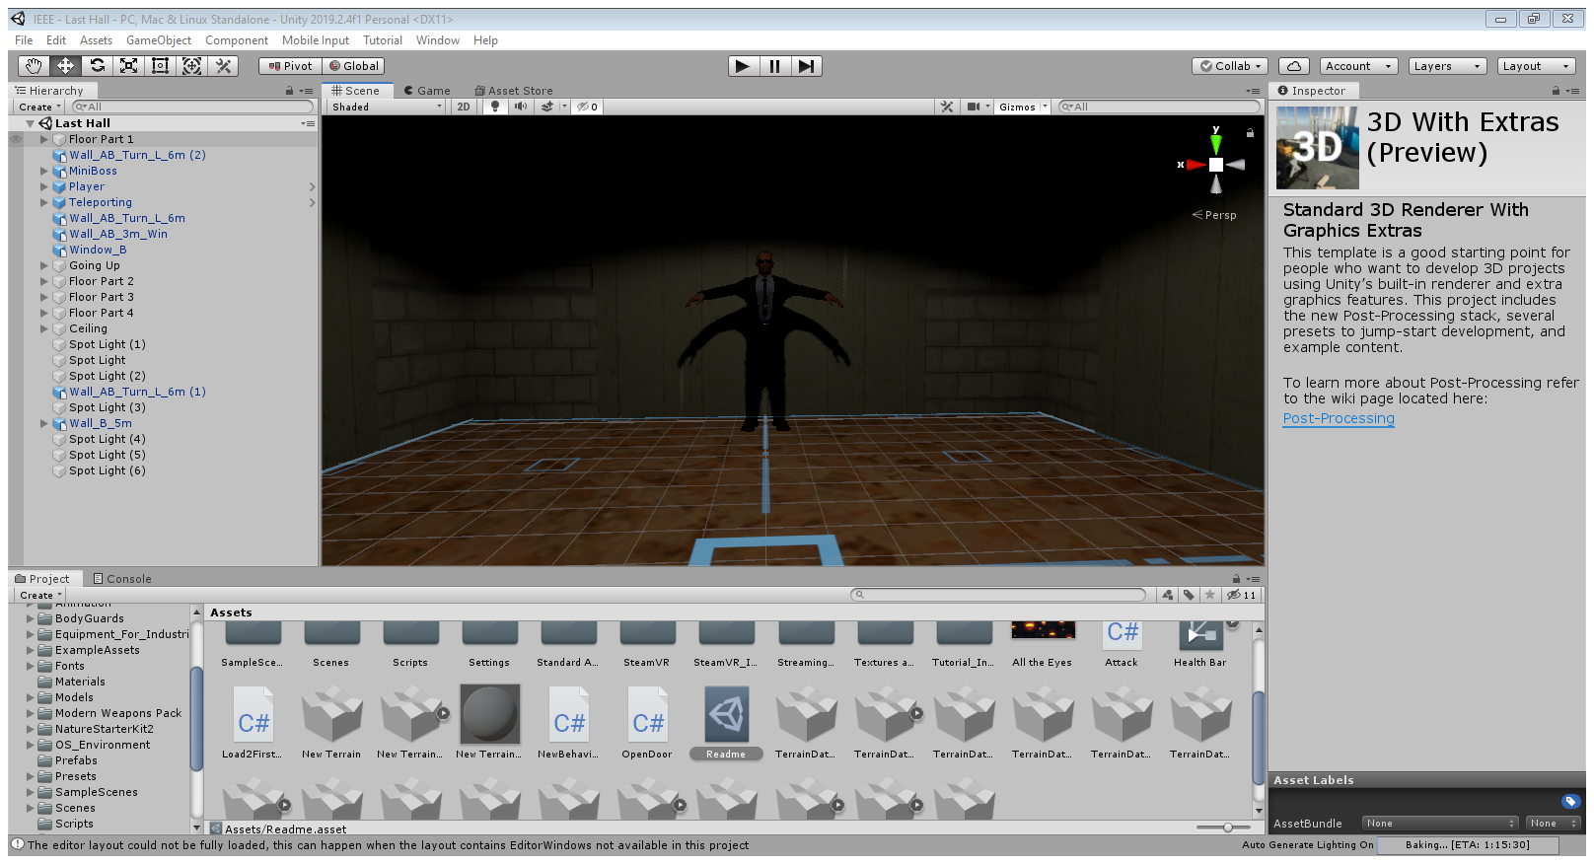

1. The Senturion in Question

Of course, the boss does not have just one Senturion at his disposal. He has two more at his disposal should the player fail the Final Exam at the end of the game. These enemies should not be taken lightly in any way, shape, or form.

## Implementation of Task 6

The penultimate task of the project involves creating the final room the player will explore in the game: the main lobby. Here, the player will explore a normal facility that completely contrasts what the player was navigating up until now. There will be NPCs to interact with as they go about their daily lives in the facility and the last encounter with the antagonist himself and an ending event that will send players over to Tyler’s virtual reality game-based learning application.

### Implementation of Subtask 6A

The main lobby is a far cry from the facilities before. While the test facility is dark and unsettling, the main lobby is calm and more peaceful. By now, the player knows this peaceful exterior hides the dark interior that is their crude testing practices on their subjects. Of course, the NPCs in the lobby are too indifferent to care about where the player came from and how they are in trouble. This scene is created the same way as the other rooms but uses the terrain definition for the floor instead. This allows the facility to be much bigger and better reflect the size of the main lobby. The terrain feature was also used as shown in the figure below. The 8 terrain squares around the facility are used to give the facility and outdoors area. The front of the building has a runway for their planes and other vehicles while the other squares show that the facility is located in a forest-like area.

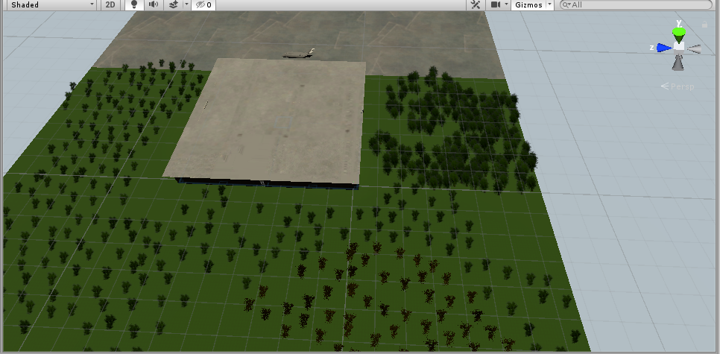

1. Outside the Main Lobby

The following two figures showcase the main lobby. The first figure shows two NPCs standing about. They are slacking off in the corridor behind the lobby, but they mean no harm to the player. The second figure shows one NPC tinkering with the facility’s equipment. He is going to ignore the player and focus on his job at hand. These figures are meant to define a semblance to normal life in an engineering facility. The NPCs are completely oblivious to the fact that they have a testing facility that does not comply with IEEE standards and can get the building shut down if exposed to the public. Instead, they would rather either focus on their job or act in ignorance to what is around them.

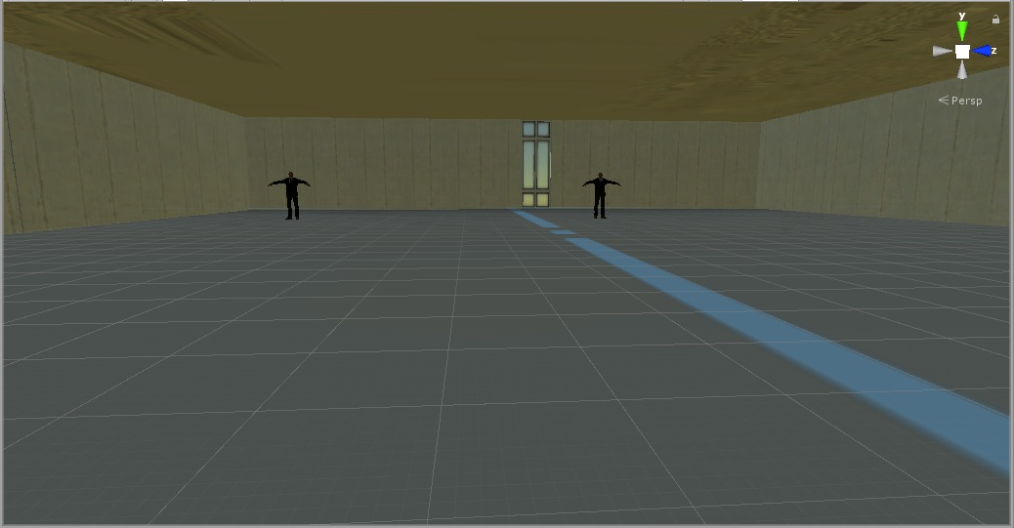

1. Two Workers Slacking

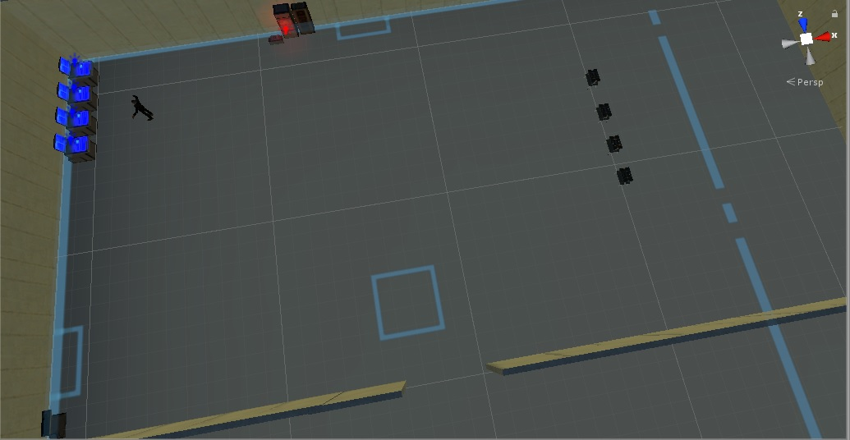

1. Overhead View of the Working NPC

The next figure showcases what is outside the front lobby of the facility. Here is a plane that is meant for employees when they are sent to other facilities around the world. This plane is defined through one of Unity’s assets and placed right outside the main lobby. Unfortunately for the player, this plane is ready to take them to an alien spacecraft somewhere in space. Regardless of the outcome of the Final Exam, the player is forced to enter the plane and be sentenced to this spacecraft. Of course, they can try to escape the spacecraft; but the premise for that escape is showcased by a similar project done in the past. This highlights the boss’s desperate attempts to keep his secrets under wraps when they could be exposed at any minute now that the player has left the harmful testing facility.

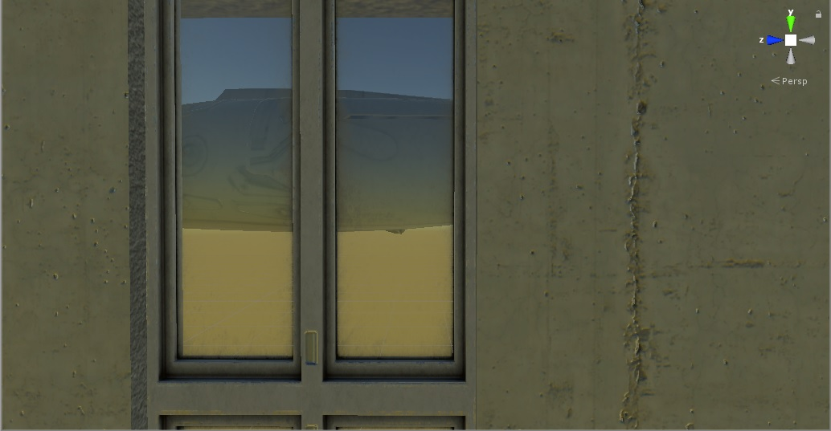

1. The Plane to Space

### Implementation of Subtask 6B

At the front of the main lobby, the player will encounter the main antagonist of the game. He is not happy with the player escaping the facility and potentially leaking his company’s secrets to the nation. This subtask implements his last stand to the player: The Final Exam. Here, the player is forced to answer 5 questions about digital logic circuits using the information learned from the puzzles as a reference. The fate of the player is determined by how many questions they get right.

Should the player get at least 4 right, they immediately clear the game, but not without being placed on the plane and out into space since the boss does not want to take any chances. On the other hand, he will summon 2 Senturions after the player should they miss more than 1 question on the Final Exam. Of course, defeating the two allows the game to end as normal.

Of course, the Final Exam is customizable. The figure below showcases the Main Menu of the game. One of the options is labeled “Final Exam Options.” Here, the professor using this game in their classroom can tailor-make their questions to suit their class. The only limitation they will encounter is that each question can only have 3 choices. From this menu, they can use the following figure to pick which of the five questions to change as well as the three options. Since this option requires a keyboard input, the menu could not be compatible with VR interfacing. Regardless, once the player starts the game, they will be ensured to put on the VR headset and begin playing the game.

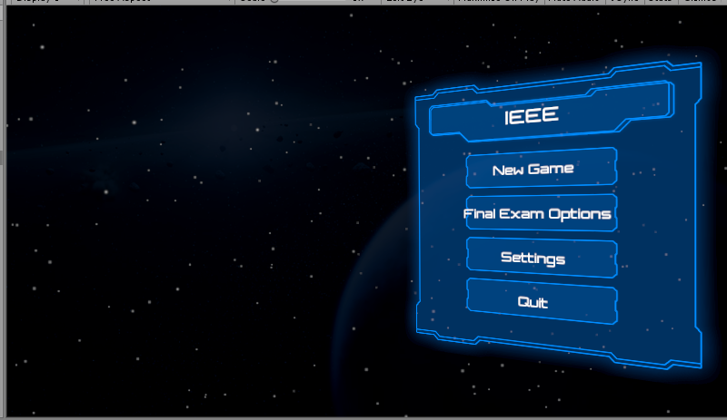

1. - The Main Menu

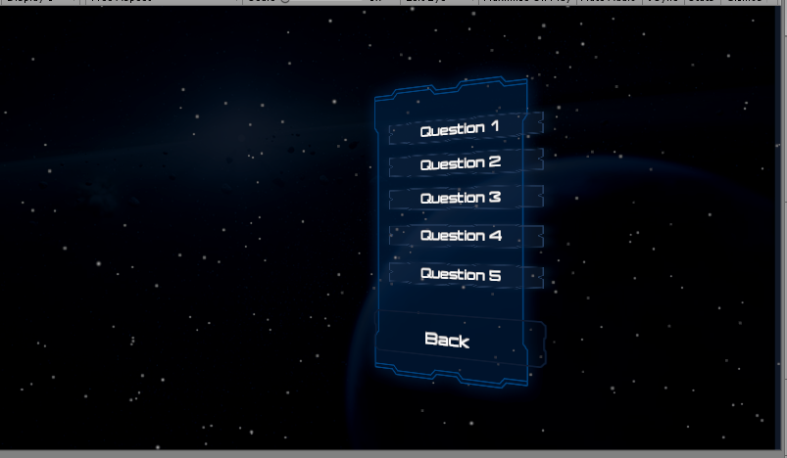

1. The Final Exam Menu

## Implementation of Task 7

The final task of this project is to simply verify that the project itself runs smoothly and as bugless as possible. Of course, with virtual reality technology still being relatively infant, a lot of issues with the technology itself often tries to interfere with the project’s completion. This section will go over some of the issues that popped up during the verification process.

The first hurdle is the HTC Vive itself. Throughout the entirety of this project, the controllers would be reversed what they are intended whenever the project was tested for each demonstration. While this problem was circumvented by just playing with the controllers backward, the problem itself still persisted and was just ignored for the sake of getting everything else done.

The second hurdle involves the testing room itself. A month into weekly testing of the program, one of the bases stopped working. As a result, the main play area for the game was significantly reduced. Of course, implementing teleportation allows easy circumvention of the problem and the game could still be tested as time went on. However, one last hurdle would constantly get in the way of this project’s potential.

One of the assets and program in this project is SteamVR. This asset allows the game to run on virtual reality. Since the technology is still relatively new, the asset would get constantly updated throughout the year. In November, however, one update caused the program itself to not run when the project is loaded on Unity. This problem persisted for a week until a hard reset of the computer allowed the SteamVR application to properly work again.

1. Conclusion (Discussion and Future Plans)

This project taught me a lot about how the video game development process works and the many issues and bugs that would pop up during the process. This project also taught me a lot more about time management and planning. And lastly, this project taught me the uphill battle one person has when making a virtual reality project alone.

This project gave me a better understanding of how video game companies make their games. It is easy to see why various tasks are split among the teams with one doing animations, one doing storytelling, one doing world-building, and so on. The ability to evenly split the work between each team allows the game to be developed in a timely manner with little to no bugs.

Likewise, the above example easily shows the uphill battle I had with developing this project. Having to work on all aspects of the project alone as well as juggling other personal responsibility like the daily commute, work back at home, and other classes does not help in that process. Looking back, the constant juggling of everything that I had to do this year provided me a better understanding of what time management really is and how it will look in the real world.

If I had the ability to, I would not mind going back to this project in the future and letting its full potential really shine. Without a strict deadline in the way, being able to fine-tune the project after the fact would allow me to go back through the bugs I had to gloss over and let my image for what the project is supposed to really shine. Like with video games today constantly getting updated, this project itself could still be worked on in the future with anyone on the helm to allow the full image of the project to really show to create the idea game-based learning environment for future engineering classes.

Acknowledgment

The assets that were used in the project will be in the Appendix below as well as their creators. For this project, I have two people I would like to acknowledge their contributions. The first acknowledgment is Chiduben who was also working on a virtual reality module for all of 2019. His assistance with the virtual reality lab and allowing the virtual reality to work allowed this project to really kick-off and not be a pile of meaningless screenshots.

The second acknowledgment is Tyler. He worked on a game-based learning VR module from 2018-2019. The ideas and execution in his own project provided motivation and influence within my own. Without learning about the SteamVR asset and teleportation, this project would have never escaped the first room of the game. His game’s setting also provided the perfect ending and sequel hook to my own.

Appendix

1. Assets Used
2. Standard Assets – by Unity
3. UI – by Unity
4. SteamVR – by Valve
5. Bodyguards – by Batewar
6. Modern Weapons Pack – by 7XF Desifn
7. Modular Factory Environment – by Ogasoda
8. Equipment for Indurtial of Science – by Sevastian Marevov
9. Nature Starter Kit 2 – by Shapes
10. Source Code.
11. Basic Enemy.cs

using System.Collections;

using System.Collections.Generic;

using UnityEngine;

using UnityEngine.AI;

public class BasicEnemy : MonoBehaviour

{

private NavMeshAgent _nav;

private Transform _player;

private BasicEnemyHealth _enemyHealth;

// Start is called before the first frame update

void Start()

{

_nav = GetComponent<NavMeshAgent>();

_player = GameObject.FindGameObjectWithTag("Player").transform; //Searches for Player Location.

_enemyHealth = GetComponent<BasicEnemyHealth>();

}

// Update is called once per frame

void Update()

{

_nav.SetDestination(_player.position); //Gives Chase to Player

/* if (_enemyHealth.HP > 0)

{

_nav.SetDestination(_player.position); //Gives Chase to Player

}

else

{

_nav.enabled = false; // Can't have dead enemies aggroing, can we?

} */

}

}

1. Basic Enemy Health.cs

using System;

using System.Collections;

using System.Collections.Generic;

using UnityEngine;

public class BasicEnemyHealth : MonoBehaviour

{

public float HP = 25; //Basic Mooks will take 3 hits

//At Base Damage 10

private Animator _animator;

void Start()

{

_animator = GetComponent<Animator>();

}

public void TakeDamage (float damage)

{

if (HP <= 0)

{

return;

}

HP -= damage; // Count the Health down.

if (HP <= 0) // Enemy Defeated

{

Death();

}

}

private void Death()

{

_animator.SetTrigger("Death");

}

}

1. PlayerHealth.cs

using System.Collections;

using System.Collections.Generic;

using UnityEngine;

using UnityEngine.UI;

public class PlayerHealth : MonoBehaviour

{

public Slider HealthBar; // Player Health Display

public float maxHealth = 100;

public float damageMod = 1; // 0.75 after 1st puzzle. 0.5 after 3rd puzzle.

private float _CurrentHealth;

void Start()

{

_CurrentHealth = maxHealth; //Set HP value

}

// Update is called once per frame

public void Damaged(float damage) // When Hit

{

_CurrentHealth -= damage * damageMod; // Enemy Damage * Damage Mod

HealthBar.value = _CurrentHealth; // = New Current Health

}

}

1. Boss Enemy.cs

using System.Collections;

using System.Collections.Generic;

using UnityEngine;

using UnityEngine.AI;

public class BossEnemy : MonoBehaviour

{

private NavMeshAgent _nav;

private Transform _player;

private BossHealth _enemyHealth;

// Start is called before the first frame update

void Start()

{

_nav = GetComponent<NavMeshAgent>();

_player = GameObject.FindGameObjectWithTag("Player").transform; //Searches for Player Location.

_enemyHealth = GetComponent<BossHealth>();

}

// Update is called once per frame

void Update()

{

if (_enemyHealth.HP > 0)

{

_nav.SetDestination(_player.position); //Gives Chase to Player

}

else

{

_nav.enabled = false; // Can't have dead enemies aggroing, can we?

}

}

}

1. Boss Health.cs

using System.Collections;

using System.Collections.Generic;

using UnityEngine;

public class BossHealth : MonoBehaviour

{

public float HP = 255; //Boss must be chufty :P

private Animator _animator;

void Start()

{

_animator = GetComponent<Animator>();

}

public void TakeDamage(float damage)

{

if (HP != 0)

{

return;

}

HP -= damage; // Count the Health down.

if (HP <= 0) // Enemy Defeated

{

Death();

}

}

private void Death()

{

_animator.SetTrigger("Death");

}

}

1. Aggroed.cs

using System.Collections;

using System.Collections.Generic;

using UnityEngine;

public class Aggroed : MonoBehaviour

{

Animator _animator;

GameObject _player;

private bool _collidedWithPlayer;

private void Awake()

{

_player = GameObject.FindGameObjectWithTag("Player"); // Search Player

_animator = GetComponent<Animator>();

}

private void OnTriggerEnter(Collider other)

{

if (other.gameObject == _player) // Mook meets player

{

_animator.SetBool("IsNearPlayer", true);

}

}

private void OnTriggerExit(Collider other)

{

if (other.gameObject == _player) // Player escapes mook

{

_animator.SetBool("IsNearPlayer", false);

}

}

void Attack() // In Combat

{

if (_collidedWithPlayer) // Mook fights player

{

_player.GetComponent<PlayerHealth>().Damaged(10); // 10 for basic mook. 20 for elite mooks. 40 for the boss.

}

}

}

REFERENCES

1. 3 Shots: This is from base player weapon stat where their damage for each shot is 10. It will increase to 30 by endgame.